FORM 2
THE PATENTS ACT,
1970 (39 of 1970)
&
THE PATENTS RULES, 2003

COMPLETE SPECIFICATION
(See Section 10; rule 13)
TITLE OF THE INVENTION
Design and Development of Prolonged Normothermic Machine Perfusion for Discarded Human Organs

APPLICANTS
S.No | Name | Address
1. | Dr. P.JEYAKUMAR | Assistant Professor,  Department of ECE,  M.Kumarasamy College of Engineering,  Karur, India-639113
2. | S.VISHWA | UG Students,  Department of ECE,  M. Kumarasamy College of Engineering  Karur, India-639113
3. | P.SUBASH
4. | V.PRADEEP
5. | S.SUBASH
The following specification particularly describes the invention and the manner in which it is to be performed.The accompanying drawings, which are included in and form a part of the specification, illustrate an incarnation of the present invention and together with the description, serve to explain the principles of the invention. In the drawings

Design and Development of Prolonged Normothermic Machine Perfusion for Discarded Human Organs

Prolonged Normothermic Machine Perfusion (PNMP) is a cutting-edge technique used in the field of organ transplantation to preserve and assess human organs that have been discarded for transplantation. This machine has the potential to revolutionize the field of organ transplantation and significantly increase the availability of viable organs for patients in need. Traditional organ preservation methods involve static cold storage, where the organ is chilled to reduce metabolic activity and extend its preservation time. However, this method is limited in its ability to maintain the organ's functionality and can lead to ischemic injury (damage caused by reduced blood flow and oxygen) during the preservation period. As a result, many potentially transplantable organs are not used due to concerns about their viability. Prolonged Normothermic Machine Perfusion addresses these limitations by providing a more dynamic and organ-specific approach to preservation. In PNMP, the donated organ is connected to a specialized machine that mimics the conditions of the human body, maintaining the organ at a normal body temperature and supplying it with a continuous flow of oxygenated, nutrient-rich blood-like solution.
Background of the Invention
Initially, organ transplantation relied on the method of cold storage, where the donated organs were preserved at low temperatures to slow down metabolism and extend their viability. While cold storage has been effective for many organ transplants, it has limitations, especially for organs that are considered marginal or less suitable for transplantation. These organs may experience significant damage during cold storage, reducing their viability and chances of successful transplantation. Normothermic machine perfusion was introduced as a potential solution to improve the preservation of liver and kidney to assess their viability before transplantation. The technique involves maintaining the organ at normal body temperature (around 37°C) and perfusing it with an oxygenated and nutrient-rich solution. This provides a more physiological environment for the organ, allowing it to function more closely to how it would inside the human body.
Objects of the invention
The objective of Prolonged Normothermic Machine Perfusion for discarded human organs is to improve the preservation and assessment of organs that have been deemed unsuitable for transplantation using traditional cold storage methods. This advanced technique involves placing the discarded organ in a specialized perfusion machine that maintains the organ at normal body temperature (normothermia) and supplies it with a carefully controlled preservation solution. The technique aims to revive and recover the function of marginal or damaged organs, which would have been discarded using traditional cold storage methods. Prolonged normothermic machine perfusion gives the organ a chance to recover from the stress of donation and surgical procedures. This method seeks to expand the pool of available organs for transplantation. By improving the preservation and assessment of discarded organs, more organs may become suitable for transplantation, reducing the waiting time and improving outcomes for patients in need of organ transplants. This minimizes the time the organ spends in a non-functional state during preservation. Reducing cold ischemia time can help improve the quality of the organ and enhance transplantation outcomes.
Summary of the Invention
Prolonged Normothermic Machine Perfusion is an advanced technique used in organ transplantation to preserve and assess discarded human organs. The process involves connecting the organ to a specialized machine perfusion system that maintains the organ at normal body temperature for an extended period. During perfusion, a specialized preservation solution is circulated through the organ's blood vessels, delivering oxygen and nutrients while removing waste products. The process allows for continuous monitoring and assessment of the organ's function and viability. This method has the potential to improve the outcomes of discarded organs by potentially reviving and making previously unsuitable organs suitable for transplantation.

Novelty
- ATP Analysis:
Semi-quantitative analysis of ATP (adenosine triphosphate) in prolonged normothermic machine perfusion (NMP) for discarded human organs is a method used to assess the energy status and viability of the organs during the perfusion process. ATP is a molecule responsible for storing and transferring energy within cells. In the context of organ preservation, the level of ATP in the organ can serve as an indicator of its metabolic activity and overall health. The semi-quantitative analysis allows for a qualitative assessment of ATP levels, providing a relative measure of ATP content rather than an absolute concentration. By monitoring ATP levels during prolonged normothermic machine perfusion, researchers and clinicians can gain valuable information about the viability and health of the discarded human organs, potentially improving the success rates of transplantation and expanding the pool of available organs for transplantation.

- HPE Examination:
Histopathological Examination (HPE) involves the microscopic examination of organ tissues or cells to assess their structure, morphology, and any pathological changes. When organs are procured from deceased donors for transplantation, they undergo a thorough evaluation to ensure their suitability for transplantation. HPE is one of the crucial steps in this evaluation process. It helps assess the quality and viability of the organ tissue, identifies any pre-existing damage or pathological conditions, and determines if the organ is suitable for transplantation. During Prolonged Normothermic Machine Perfusion, HPE may be performed on tissue samples obtained from the perfused organ at specific time points during the perfusion process. The examination allows the assessment of the organ's response to perfusion, the effects of reperfusion injury, and any changes in the tissue over time. The grading and interpretation of histopathological findings play a significant role in deciding whether the organ is suitable for transplantation or if it needs to be discarded.

- Cytokine Filter:
The potential use of cytokine filters during NMP could be to mitigate the inflammatory response in the perfused organ and reduce the risk of ischemia-reperfusion injury. By removing excessive cytokines from the perfusate, the filters may help protect the organ from inflammatory damage and improve its viability for transplantation. Cytokine filters work based on the principle of adsorption, where certain substances are selectively removed from the blood as it passes through the filter. The filter contains specific materials that can bind and remove cytokines and other inflammatory mediators from the blood. By doing so, the cytokine filter helps modulate the immune response and reduces the levels of harmful cytokines in the circulation.

Brief Description of the Drawings

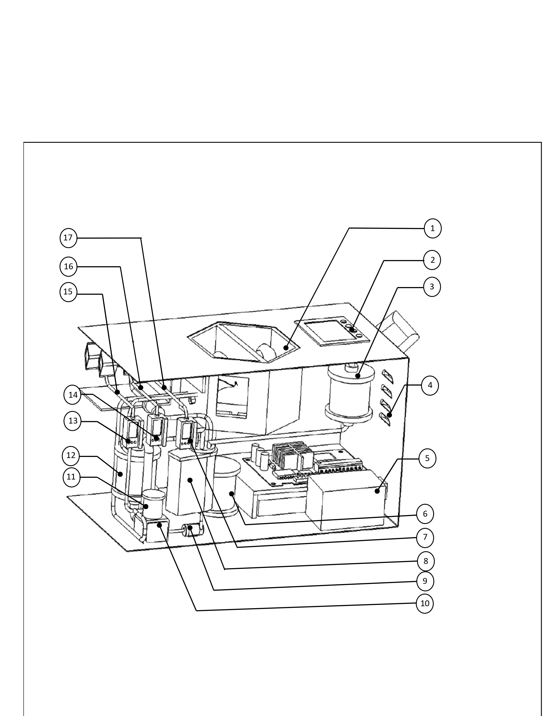

- Organ Basin:
The purpose of the organ basin is to hold the organ, in this case, the kidney, safely and securely during transportation from the donor to the recipient. The organ basin is typically made of a sterile and biocompatible material to ensure that it does not interact negatively with the organ or preservation solution. It is designed to keep the kidney immersed in the preservation solution. During kidney transplantation, once the donor kidney has been removed from the donor's body, it is flushed with the preservation solution to remove blood and debris. The kidney is then placed in the organ basin, and the basin is filled with the preservation solution, completely submerging the organ. This immersion ensures that the kidney is kept in a cold, oxygenated environment, which slows down the organ's metabolic processes and helps preserve its functionality.
The organ basin is usually sealed securely to prevent any leakage of the preservation solution during transportation. It also helps protect the kidney from physical trauma that could occur during transit.
- Display:
The purpose of the display is to show the essential parameters necessary for preserving the organ during Prolonged Normothermic Machine Perfusion. These parameters include oxygen levels, pressure, ATP results, and HPE parameters. Having this information displayed is highly beneficial for doctors as it enables them to monitor and care for the organ effectively, based on the indicated parameters.
- Cleanser Unit
A cleanser unit refers to a component or system within the machine perfusion setup that is responsible for cleaning and filtering the organ basin before and after it is used to preserve the discarded human organ. The cleanser unit plays a crucial role in maintaining the quality of the organ basin and ensuring that it remains free from impurities, debris, and harmful substances. This is important because the organ basin is in direct contact with the discarded organ, and any contamination or buildup of toxins could negatively impact the viability and health of the organ during the preservation process.

The cleanser unit typically consists of filters and purification mechanisms that remove unwanted particles, bacteria, and other contaminants from the basin. This ensures that the organ basin remains oxygenated, sterile, and well-balanced with nutrients to support the organ's cellular function and viability. By employing a cleanser unit in the PNMP system, medical professionals can maintain optimal conditions for the organ throughout the preservation period, increasing the chances of successful transplantation and potentially expanding the pool of available organs for transplantation.

- Air Filters:

Air filters are often utilized to remove carbon dioxide and other waste gases from the perfusion system while providing a continuous supply of oxygen. These filters help maintain a controlled and sterile environment for the organ during the perfusion process. The filters ensure a continuous flow of oxygen into the perfusion system, enabling the organ to receive a constant supply of oxygenated blood or preservation solution, which is essential for its viability and function. As the discarded organ continues to metabolize during normothermic machine perfusion, it produces waste gases such as carbon dioxide. The air filters help remove these waste gases from the system to prevent their accumulation, maintaining optimal conditions for the organ.The air filters play a role in preventing the introduction of contaminants and pathogens into the perfusion system. This is particularly important to maintain a sterile environment for the organ, reducing the risk of infections and complications.
- PMS Unit
A power management system unit is component that is responsible for managing and supplying power to the machine perfusion system. The power management system unit is a critical part of the machine perfusion setup because it ensures a stable and reliable power supply to all the components and instruments involved in the process. It typically includes power sources, voltage regulators, circuit protection, and other electrical components to manage the power distribution and prevent damage to the system. A reliable power management system is essential during PNMP, as any power failure or instability could compromise the viability of the discarded organ and render it unsuitable for transplantation.

- Heaters :
Kidney preservation kits are designed to keep the organs at a specific temperature during transportation from the donor to the recipient. The preservation solution used in these kits, such as University of Wisconsin (UW) solution or Euro-Collins solution, provides a cold and oxygenated environment to slow down the metabolic processes and preserve the kidney's viability.
The preservation solution itself is pre-chilled to a specific temperature and is intended to keep the kidney cold, typically between 0 to 4 degrees Celsius (32 to 39 degrees Fahrenheit). This helps to minimize the metabolic demand of the organ, extending its preservation time outside the body. Heating elements are generally not used in these kits because warming the kidney could accelerate metabolic processes, potentially leading to organ damage. The goal is to slow down cellular activity and prevent damage during transportation, rather than trying to revive the organ before transplantation.
- HA Pressure monitor
The HA pressure monitor is a device used to measure and monitor the pressure within the hepatic artery, which is the blood vessel responsible for supplying oxygen-rich blood to the liver. Monitoring the HA pressure during the perfusion process can provide valuable information about the vascular condition of the organ, as well as its response to the perfusion procedure. By closely monitoring the HA pressure, transplant teams can gain insights into the organ's function, perfusion stability, and potential areas of concern. Abnormalities in the HA pressure during the perfusion process may indicate issues such as vascular resistance, vascular injury, or potential problems in the blood supply to the liver. Having this real-time information can aid transplant surgeons and medical professionals in making critical decisions about the viability and suitability of the organ for transplantation.

- Reservoir:
A reservoir typically refers to a container or compartment within the preservation kit that holds the preservation solution. This reservoir is specifically designed to store and protect the kidney during transportation from the donor to the recipient, ensuring the organ remains in a cold and oxygenated environment. When a kidney is procured for transplantation, it is removed from the donor's body and placed in the preservation solution. The preservation solution, such as University of Wisconsin (UW) solution or Euro-Collins solution, is a specialized fluid that helps to preserve the kidney by slowing down its metabolic processes and minimizing damage during transportation.
The kidney is usually placed in a sterile bag or container, and this bag or container serves as the reservoir where the preservation solution is held. The reservoir is then sealed and kept at a specific temperature. The use of a reservoir in kidney preservation kits is critical for maintaining the organ's viability and ensuring its successful transplantation into the recipient. The reservoir helps to create an optimal environment for the kidney during the transportation period, which can sometimes involve long distances or extended periods of time.

- Rotaflow pump
The Rotaflow pump is a specialized medical device designed for extracorporeal circulation, specifically in extracorporeal life support (ECLS) systems such as extracorporeal membrane oxygenation (ECMO). It operates using the principle of centrifugal force to facilitate the movement of blood or other fluids through the pump. At the core of the Rotaflow pump is a spinning motor that rotates at high speeds. This motor is connected to an impeller or rotor, which is a set of curved blades. As the motor spins, the impeller also rotates rapidly. When the impeller rotates, it creates centrifugal force. Centrifugal force is an outward force experienced by an object moving in a circular path. In the case of the Rotaflow pump, this force pushes the blood or fluid away from the center of rotation, towards the outer edge of the impeller. Blood or other fluids are introduced into the pump at the center, where the impeller is located. As the impeller spins, the centrifugal force generated pushes the blood towards the outer edge of the impeller. Near the outer edge of the impeller, the pump is designed with an outlet that directs the flow of blood or fluid away from the pump. As the blood moves towards the outlet, it gains energy from the spinning impeller, and this energy transfer helps propel the blood or fluid out of the pump and into the patient's circulatory system. The Rotaflow pump is commonly used in ECMO and other ECLS systems, where it assists or temporarily replaces the function of the heart and/or lungs. It allows the patient's blood to be continuously circulated, oxygenated, and filtered, providing support to vital organs during critical conditions when the patient's own circulatory or respiratory systems are compromised. The Rotaflow pump's efficient and continuous blood flow management is crucial in ECLS scenarios, as it helps maintain tissue perfusion, oxygenation, and carbon dioxide removal, supporting the patient's overall stability and recovery. Its precise design and performance make it a valuable tool in modern medical practice for managing critically ill patients in need of extracorporeal life support.

- IV fusion pump
An infusion pump is a medical device that delivers fluids, including medications, nutrients, or other therapeutic solutions, into a patient's body in a controlled and precise manner. In the context of PNMP, the IV fusion pump could be used to deliver a carefully controlled solution to the preserved organ, ensuring it receives essential nutrients and medications to maintain its function during the perfusion process.

- Oxygenator:
The preservation solution is usually oxygenated before it is used to flush and store the kidney. This is done to ensure that the organ receives the necessary oxygen while outside the body, despite not being actively perfused as it would be inside a living organism. The oxygenation process involves bubbling oxygen or another gas mix through the preservation solution before it is used to flush and store the kidney. This helps maintain the viability of the kidney during the preservation period.
During transportation, the kidney is typically stored in a sealed container or bag with an oxygenated preservation solution. While the preservation solution is oxygenated, it is not an oxygen-delivery system like an oxygenator used during surgical procedures involving the heart and lungs. The kidney is not actively perfused with oxygenated blood during preservation; instead, it relies on the oxygen present in the preservation solution.
- Cytokine filters
Cytokine filters are a type of filtration device designed to remove cytokines and other inflammatory mediators from the bloodstream. Cytokines are small proteins that play a crucial role in cell signaling and the immune response. However, excessive and uncontrolled release of cytokines can lead to a harmful immune system reaction, known as a cytokine storm, which can cause significant tissue damage and organ dysfunction. The use of cytokine filters in PNMP will potentially be explored to mitigate the impact of cytokine release during the preservation process. By removing excessive cytokines and inflammatory mediators from the perfusate, the filters may help reduce inflammation and protect the organ from damage, potentially improving its post-transplant outcomes.

- PV Pressure monitor
A PV pressure monitor would likely be used to measure the pressure within the portal vein, which is a major vein that carries blood from the digestive organs to the liver. Monitoring the PV pressure during machine perfusion can provide valuable information about the condition and function of the organ being preserved. Changes in PV pressure could indicate vascular resistance, congestion, or other issues that may affect the viability and suitability of the organ for transplantation. By continuously monitoring the PV pressure, medical professionals can make real-time adjustments to the perfusion parameters, including flow rates and solution compositions, to optimize the preservation process and maintain the organ in the best possible condition for transplantation.

- Medication Probe
It is used to dilate blood vessels and improve blood flow through the organ. This can help maintain organ function and reduce the risk of ischemia (inadequate blood supply) during PNMP. Drugs that prevent blood clotting can be used during PNMP to prevent blood clots from forming within the organ or the machine's tubing, which could impair the perfusion process. These medications may be used to reduce oxidative stress and protect the organ from damage caused by free radicals generated during the perfusion process. Anti-inflammatory Agents: Drugs that help reduce inflammation may be administered to minimize inflammation-related damage to the organ during PNMP.

- PV Infusion
The discarded human organ is connected to a perfusion machine through its blood vessels, including the portal vein. The portal vein supplies blood to the liver and intestines and is an essential vessel to monitor during liver perfusion. By infusing a preservation solution through the portal vein, the perfusion machine can help deliver oxygen, nutrients, and other essential substances to the organ, keeping it functioning optimally during the preservation process. The infusion of a preservation solution or medications directly into the veins of the discarded organ. This method allows for precise delivery of substances into the organ to maintain its function and viability during the PNMP process.
- HA Infusion
Hyaluronic Acid is a natural substance found in the body that has been used in various medical applications, including in some surgical and regenerative medicine procedures. It will help to reduce inflammation and oxidative stress during organ preservation, potentially improving organ quality and function. It is known for its ability to promote tissue repair and regeneration. In the context of organ transplantation, it might aid in the recovery and restoration of damaged tissues within the organ. It is a hydrophilic molecule, meaning it attracts and retains water. This property can help maintain tissue hydration during PNMP, which is crucial for preserving organ integrity.
- Auxiliary Port
This port will allow medical professionals to take samples of the perfusion solution and the organ's perfusate to assess the organ's metabolic status and overall condition during the perfusion process. It will be used to administer medications or other agents directly into the perfusion circuit to assess their effects on the organ or to provide targeted treatments. It is used to connect various monitoring devices to measure parameters such as oxygen levels, pressure, temperature, or other relevant indicators to ensure optimal perfusion conditions. It enables medical professionals to conduct biopsies or other assessments of the organ during the perfusion process to evaluate its quality and function.

Claims
I/We Claim,
Our claim is to create an extended normothermic machine perfusion (PNMP) system for Discarded Human Organs. The PNMP mechanism used in our approach closely mimics physiological conditions. Additionally, we integrated multiple sensors to continuously monitor and display essential organ parameters such as oxygen levels, pressure, and other vital indicators necessary for normal organ function.
Signature of Applicants:
Dr.P.JEYAKUMAR | S.VISHWA | P.SUBASH | S.SUBASH | V.PRADEEP

Abstract
Prolonged normothermic machine perfusion (PNMP) has emerged as a promising technique for the preservation and assessment of discarded human organs intended for transplantation. Traditional cold storage methods have limitations in maintaining organ viability, particularly for extended periods, resulting in a significant number of viable organs being discarded. PNMP offers a potential solution to this critical issue by providing a continuous oxygenated perfusion of discarded organs at normal body temperature, thereby replicating physiological conditions and supporting cellular function. There are so many advantages of PNMP over conventional cold storage techniques. By maintaining organs at normothermic conditions, PNMP provides continuous organ assessment, which allows for real-time monitoring of organ function and viability. Furthermore, PNMP extends the preservation time, offering more flexibility in organ allocation and transportation, and potentially increasing the pool of available organs for transplantation.

